Liela Pressley
ITT-116
Instructor Joel
3 July 2022
- How many network connections are available by default on this system?
  - There are about 20 virtual network connections available but 5 different network connectivity options such as bridged, NAT, Host-only (private), Custom and LAN Segments.
  - 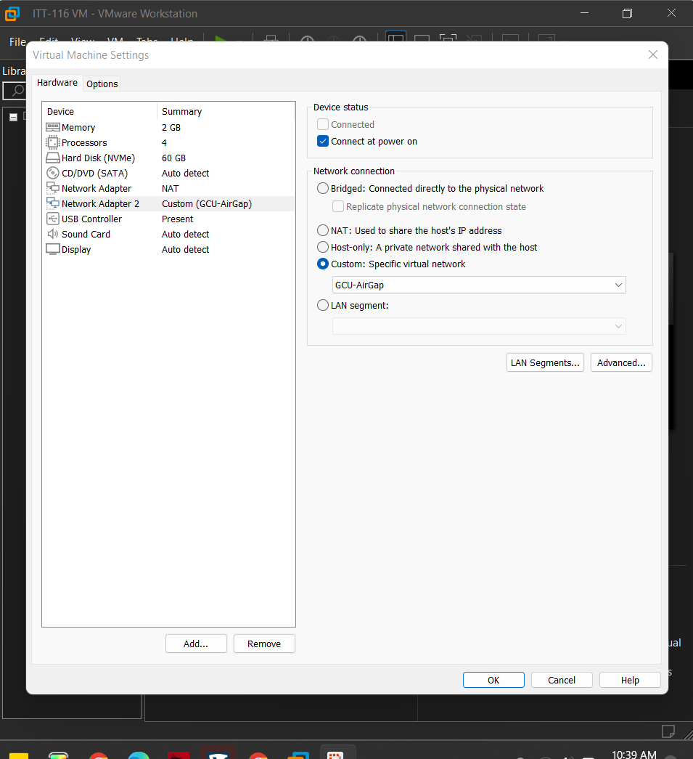
- Which ones are used by the operating system to connect to the host?
  - NAT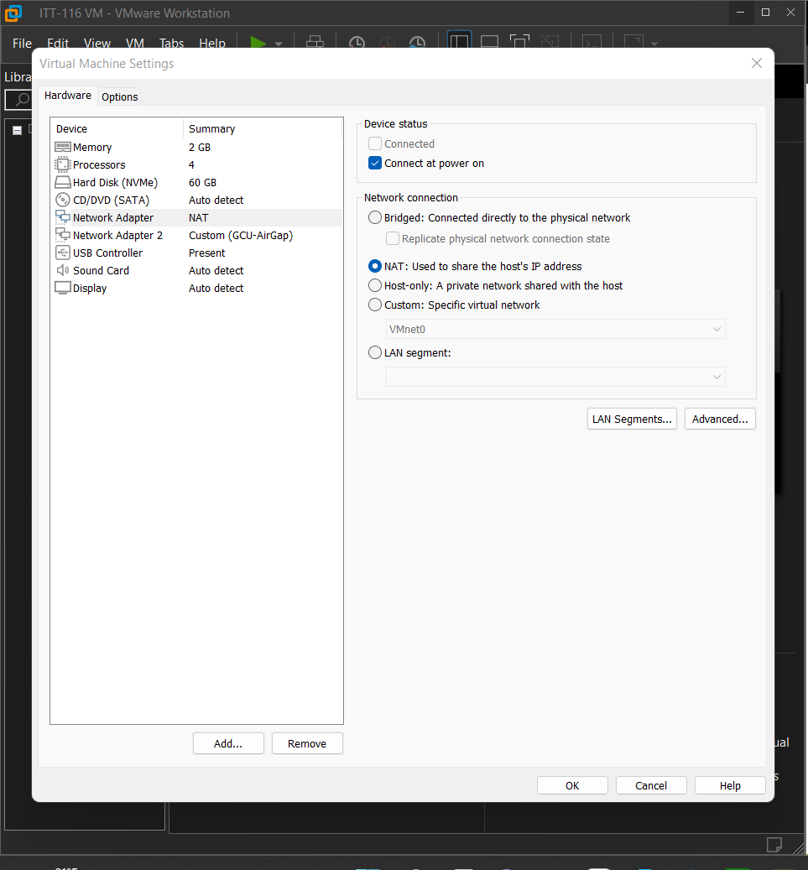
- What is the difference between the host system and the virtualized system?
  - The host system runs on the laptop hardware and the virtualized system runs on virtual hardware within the software.
- If you need to isolate this virtualized system in order to create an airgapped system, what might you do?
  - An air-gapped system is isolating a system (computer, network storage) from insecure networks. I would go to the VirtualMachine settings, select Guest isolation and disable the ability to drag and drop/copypaste files between systems and ensure that the Network Adapter is connected to a custom private network.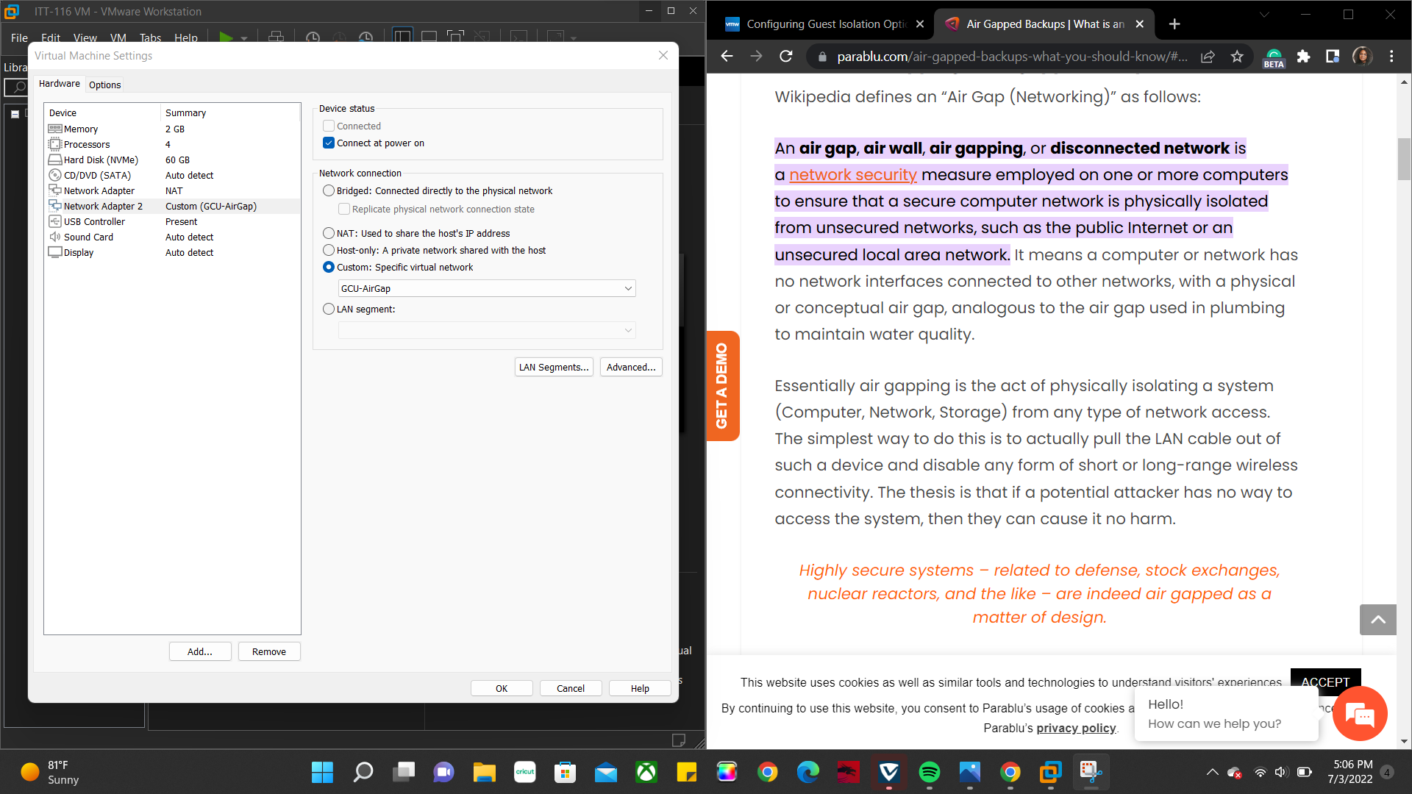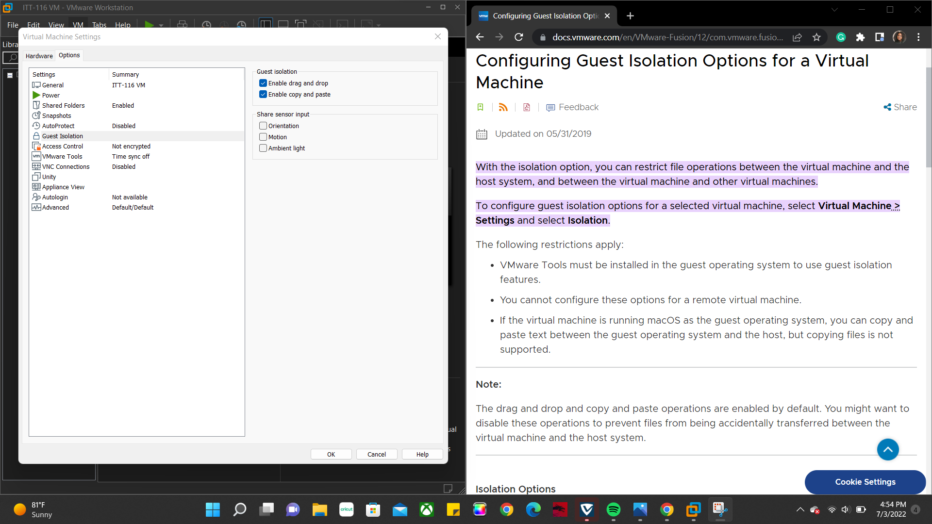
- What is the Internet Protocol (IP) address of the system?
  - The IPv4 address is: 192.168.152.128
- What is the IP address of the host system?
  - 192.168.10.128
- What are the other address details for each system?
  - Host- DNS server address: 192.168.10.254, physical address: 00-0C-29-9A-1E-91,DHCP: 192.168.10.254
  - VM- DNS server: 192.168.152.2, physical address: 00-0C-29-9A-1E-87, DHCP: 192.168.152.254
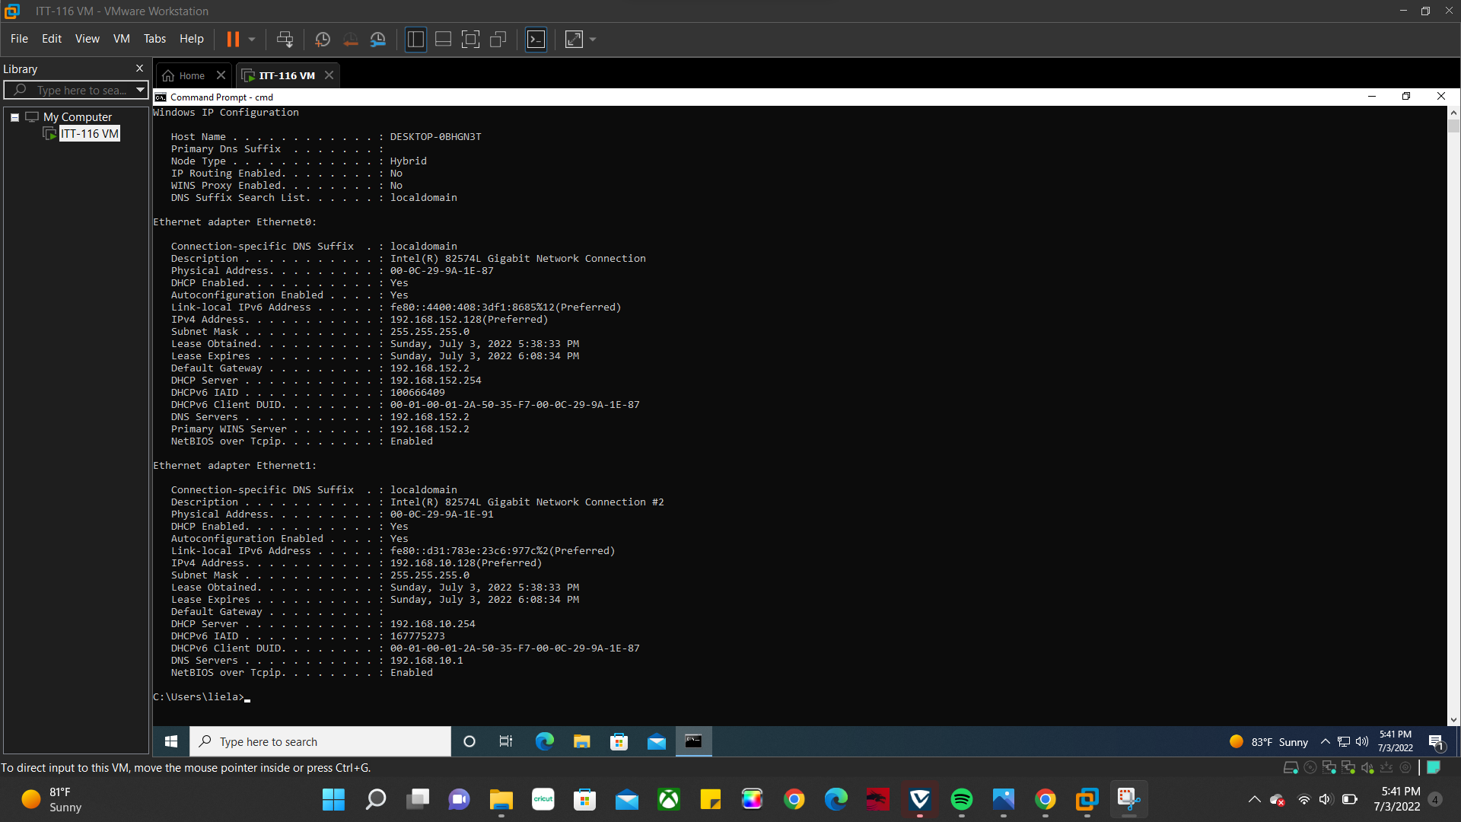
- Explain what a Domain Name Server (DNS) and Dynamic Host Configuration Protocol (DHCP) are.
  - Domain Name Server translates domain names to IP addresses so browsers can load Internet resources. It converts a hostname (www.blank.com) into an IP address which is given to every device on the network (cloudfare, n.d.). Dynamic Host Configuration Protocol is a network management protocol that dynamically assigns IP addresses to devices on a network in order to use IP (Gillis, 2019).
- Identify the MAC address for each system. What is the MAC address?
  - VM: 00:0C:29:9A:1E:91
  - HOST: 00:0C:29:9A:1E:87
  - Media Access Control Address is a hardware number of a computer that has a NIC (Network Interface Card). This 12-digit number is the physical address of a device used by the Data-Link Layer used for identification and for the MAC protocol (GeeksforGeeks, 2022).
References
cloudfare. (n.d.). What is DNS? | How DNS works. Retrieved July 3, 2022, from https://www.cloudflare.com/learning/dns/what-is-dns/
GeeksforGeeks. (2022, June 3). Introduction of MAC Address in Computer Network. Retrieved July 3, 2022, from https://www.geeksforgeeks.org/introduction-of-mac-address-in-computer-network/
Gillis, A. S. (2019, December 3). DHCP (Dynamic Host Configuration Protocol). SearchNetworking. Retrieved July 3, 2022, from https://www.techtarget.com/searchnetworking/definition/DHCP#:%7E:text=DHCP%20(Dynamic%20Host%20Configuration%20Protocol)%20is%20a%20network%20management%20protocol,they%20can%20communicate%20using%20IP.

